Business Question and Visualization Report

Date | 18 September 2026
Team ID | MCA
Project Name | Smartphone Usage, Digital Addiction & Well-Being Analytic
Maximum Marks | 5 Marks

The system lifecycle incorporates data visualization development techniques to translate raw digital tracking matrices into actionable business intelligence formats. By designing customized chart layouts, cross-filtering controllers, and balanced color scales, the platform exposes complex behavioral dependencies clearly to facilitate strategic decision-making and product optimization. Transforming multi-layered datasets into structured visual assets simplifies information extraction and helps research panels identify hidden user behaviors. Selecting optimal dashboard matrices directly strengthens data-driven discoveries, turning passive device indicators into robust analytical assets.
Business Questions and Visualisation
This module establishes key analytical hypotheses to guide dashboard composition within Power BI, ensuring every visual module targets specific behavior trends, performance indicators, or user risk profiles. Well-framed target questions ensure the reporting pipeline surfaces meaningful, action-oriented findings that pinpoint exact device habits across the user network.
What is the distribution of daily screen time among users? | Histogram showing daily screen time distribution | 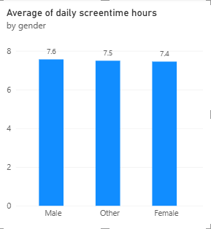
 | Column chart comparing average screen time by age group | 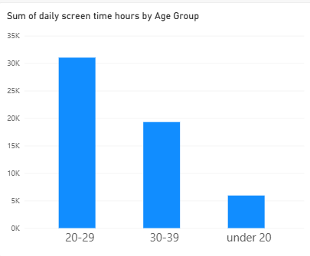
  Which age groups have the highest average daily screen time?
 | Clustered column chart comparing social media and gaming hours | 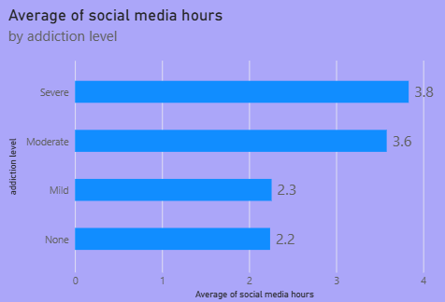
  How does social media usage compare with gaming usage?
What is the relationship between screen time and digital addiction? | Scatter chart showing screen time vs. digital addiction | 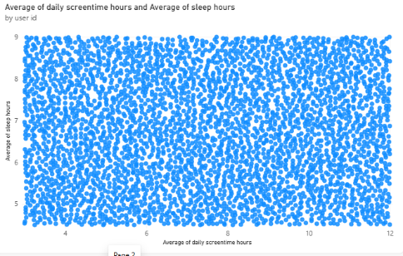
How does stress level vary with digital addiction? | Stacked column chart showing stress level by addiction level | 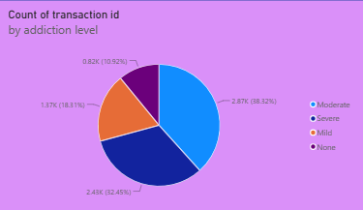
How does smartphone usage affect academic or work activities? | Bar chart showing academic/work impact by addiction level | 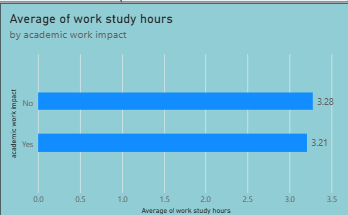
How does weekend screen time compare with daily screen time? | Bar chart comparing daily and weekend screen time | 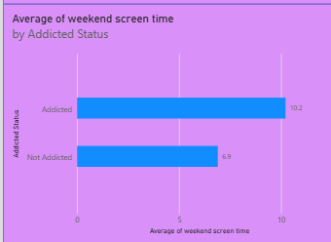
Which user group has the highest digital addiction level? | Bar chart showing users by addiction level | 